
WHITEWATER RAMBLE
Private Event
Music Guide
Colorado-grown high-octane Rocky Mountain dancegrass
for weddings, parties & private events
RECEPTION • COCKTAIL HOUR • CEREMONY • SPECIAL REQUESTS
This guide explains how we approach song selection, set flow, ceremony music, cocktail hour, and special requests so the music feels custom to your event while still giving the band room to read the room and keep the party moving.

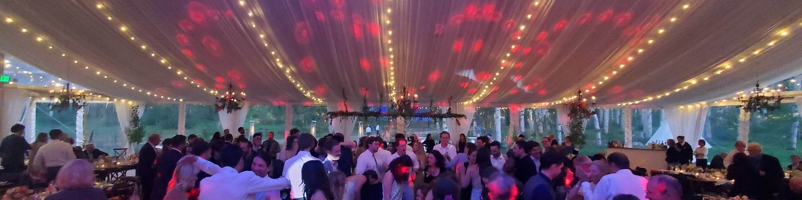
OUR APPROACH
Not a novelty bluegrass cover band.
WhiteWater Ramble features mandolin, fiddle, acoustic guitar, upright bass, and banjo-style textures, but the band also includes drums, electric instrumentation, multiple lead vocalists, harmonies, and multi-instrumentalists. When we cover rock, Americana, reggae, pop, or jam material, we lean into the moment and the room. | We play to the room,  the moment, and the  party.
SONG SELECTION
How We Build the Night
Couples receive access to our active song list, which includes 200+ songs and continues to grow. Your selections help us understand your style, favorite artists, and the musical fingerprint you want for the night.
1. Redlines  Mark any songs you absolutely do not want performed. These are your redlines. | 2. Favorites  Highlight roughly 30 songs you both like. These guide the vibe but are not a guaranteed setlist.

3. The Setlist  We build the framework around your favorites, redlines, proven crowd material, and the natural energy of the evening. | 4. Live adjustments  The final set evolves in real time based on the dance floor, the crowd, and the moment.

A great dance set has an arc.
We usually start with strong energy while still leaving room to build. If a 90s alternative song lights up the floor, we may lean further into that era. If a reggae tune clears the floor, we move in a different direction. The band adjusts volume, pacing, and song choices to match the room.

CLIENT FAVORITES
A better way to shape the night.
Ballads and slower songs  Ballads and slower songs can be beautiful in the right moments, but too many can slow the momentum of the night. We may place slower favorites earlier, during cocktail hour, during dinner-style moments, or in a short featured moment rather than stacking too many into the main dance-party portion of the reception.  Favorite artists and deep cuts  If you love a specific artist or band, that is great context for us. But circling every song by one artist may not always translate to the best full-room experience. We use your favorite artists as guidance while still building a set that works for the whole audience.  Popular covers vs. originals  Reception performances are built primarily around popular, recognizable cover songs unless otherwise discussed. WWR originals are always welcome when requested and are not counted as special requests. | 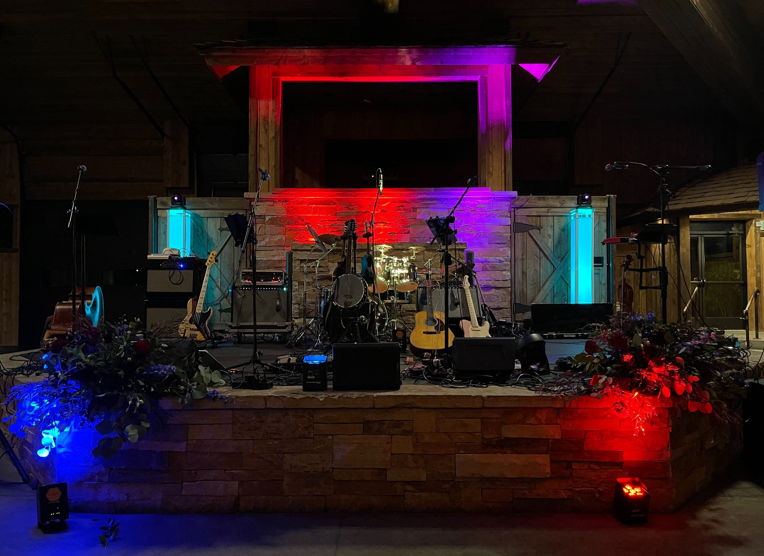
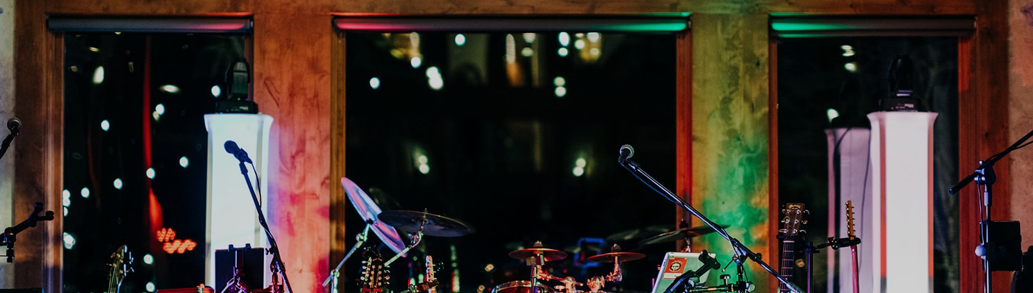
Reception
5-PIECE FULL BAND | 3 TO 3.5 HOURS TOTAL | TWO SETS WITH A SHORT BREAK
A typical reception performance includes bass, drums, guitar, mandolin, fiddle, vocals, harmonies, and acoustic/electric instrumentation. Reception music is focused on well-known songs that connect with the full audience. The band builds from your song-list favorites and adjusts live to maintain momentum.
BEST FOR: DANCING + FULL-BAND ENERGY

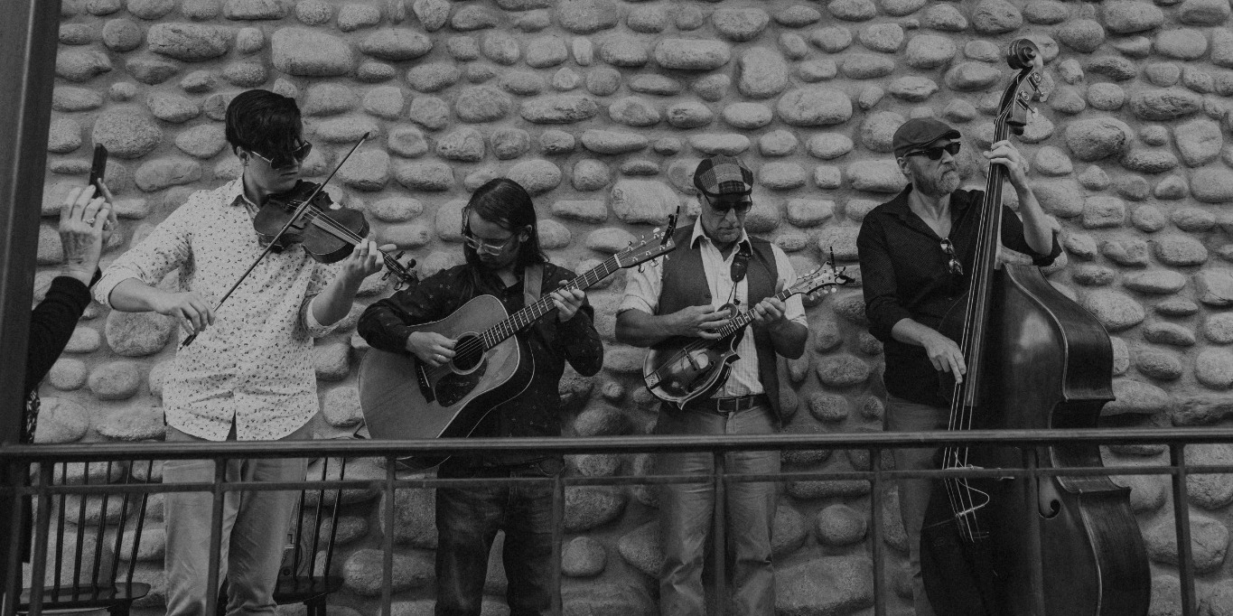
Cocktail Hour
4-PIECE ACOUSTIC ENSEMBLE | 45-75 MINUTES | ROAMING / UNPLUGGED STYLE
Cocktail hour selections  The band typically curates cocktail hour based on the feel of the event, the setting, and the songs that work best in an acoustic environment. We also use the couple’s request list as guidance, especially for favorites that may not be upbeat enough, dance-focused enough, or ideally suited for the main reception set. | Where softer favorites shine  A beautiful slower favorite, folk-leaning song, or more intimate selection may not be the best choice during the peak dance-party portion of the evening, but it may be perfect during cocktail hour.
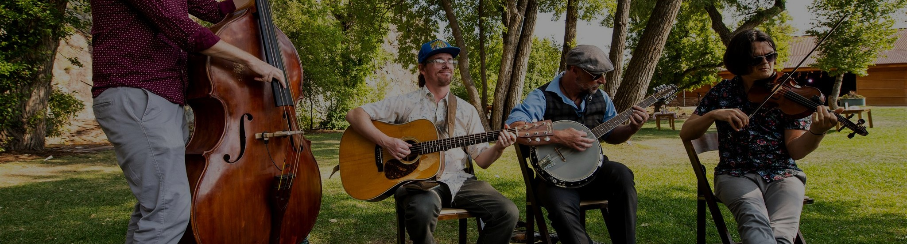
Ceremony
4-PIECE ACOUSTIC INSTRUMENTAL ENSEMBLE | PRELUDE BEGINS 15-20 MINUTES BEFORE CEREMONY
Ceremony music is typically performed by acoustic guitar, mandolin, fiddle, and upright bass. The performance is instrumental, elegant, and arranged for the setting. Two ceremony special requests are included: one processional and one recessional. Acoustic performance is often possible without power; amplification is available when needed.

SPECIAL REQUESTS
Personal moments, arranged with intention.
Special requests are songs not currently on the band’s active song list that you would like us to perform. They do not need to be finalized when booking; it is very common for couples to decide on these later.
Reception requests  Couples are allotted up to 3 reception special requests. These are often used for a first dance, parent dances, a final dance, or a meaningful song to feature during the night. | Ceremony requests  If ceremony music is part of your package, 2 ceremony special requests are included: processional and recessional. These are arranged specifically for acoustic instrumentation. |  | Timing  Please finalize special requests approximately 30 days before the event so the band has time to arrange, rehearse, and place them properly in the event flow.
For formal dances, we often recommend shortened versions around 2.5 minutes.
This keeps the moment meaningful while maintaining the flow of the evening.
Additional requests  Additional special song requests may be possible for an added cost depending on the number of songs, difficulty, instrumentation, arrangement needs, and available rehearsal time. WWR reserves the right to decline requests if a song is not a good fit for the instrumentation, vocal range, event moment, or available preparation time.  Spotify, playlists, and formal moments  Many couples use a combination of live music and playlist-based music. Spotify or downloaded playlists can work well for grand entrances, dinner music, set-break music, formal dances, after-party music, or any song that needs to be the exact original recording. |  | 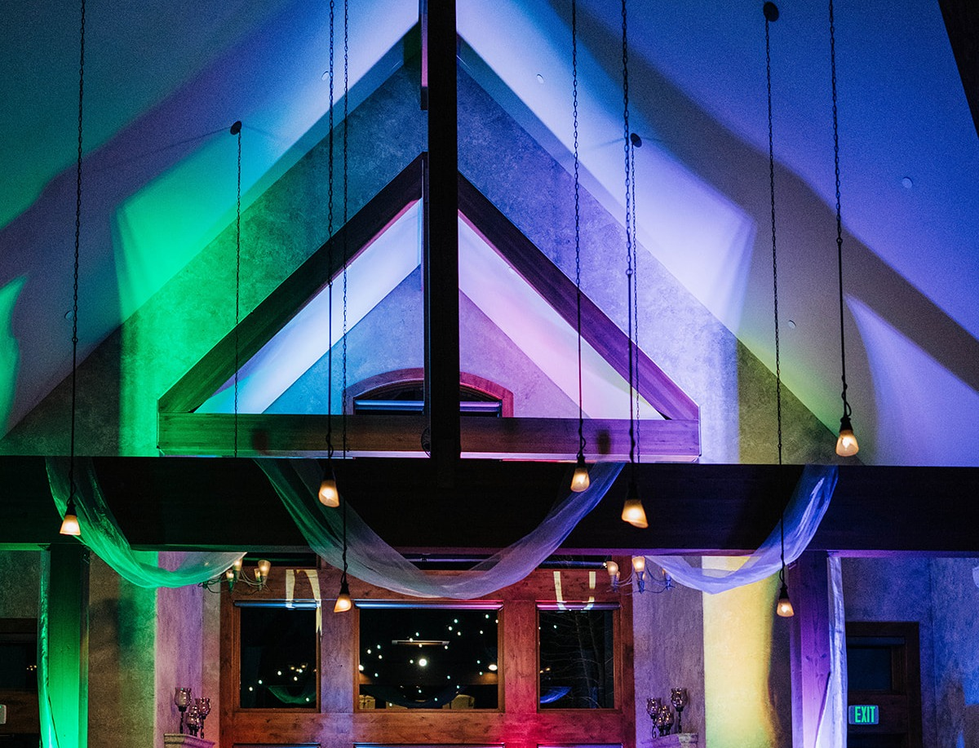

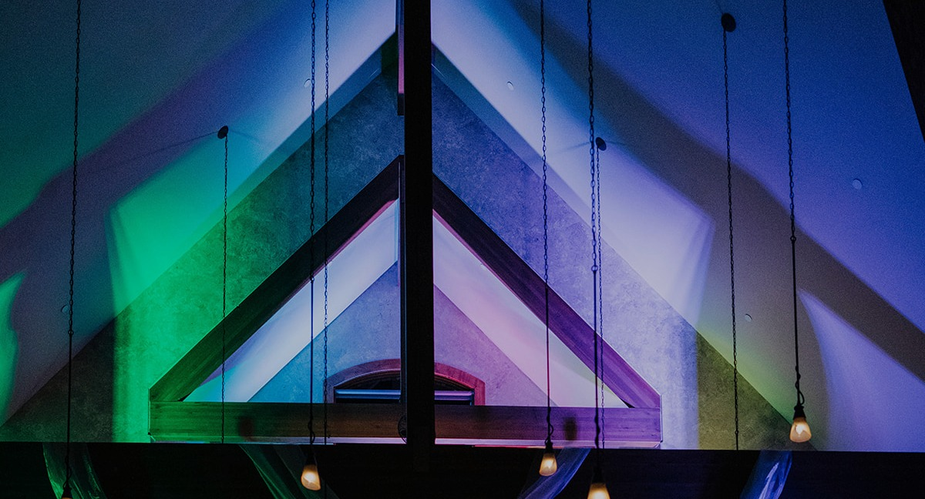
THE BIG PICTURE
A night that feels personal,
energetic, and alive.
Your song choices, redlines, and special requests give us the musical fingerprint of the event. From there, we build a live performance that fits the room, follows the energy, and helps create the kind of celebration people remember.
Thank you for considering WhiteWater Ramble for your event. We are always happy to answer questions, talk through song ideas, and help shape the right musical experience for the day.

