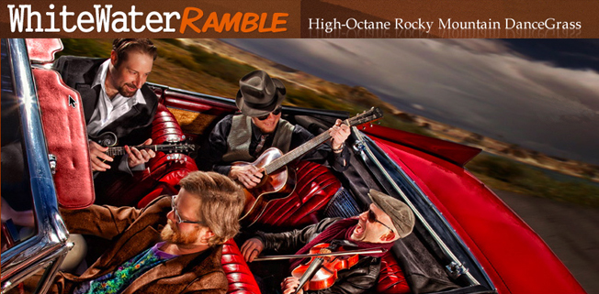

Quotes:

“WWR have their feet planted in more than one world. More than two if you count such things and sometimes all at the same time! No matter which world you prefer; bluegrass, rock, electronica or the myriad combinations, WWR will take you there on a fantastic ride! “
~Tim Carbone – Railroad Earth

"With a list of influences that reaches into every corner of contemporary music, from reggae to blues to country and beyond, WhiteWater Ramble pushes the boundaries of the form way past the edge. It ain't your grandpappy's jug-band music anymore, now it's jam-grass."
~ The Boulder Daily Camera

"Certainly, playing across genres gives WhiteWater Ramble a much broader appeal and helps to win over those who may not necessarily be fans of bluegrass.“
~ Vail Daily News

“Whitewater Ramble shatters notions of what an acoustic band sounds like on its first studio release”
~ Dutch Seyfarth – The Westword

WWR is renowned for putting on passionate and remarkable shows...They were able to gather their energy from the stage in the production of their magnificent debut studio album, All Night Drive.
~ Derek Siegel – Hittin’ The Note

"The style is firmly jamgrass - a touch of Salmon, a dash of Yonder , a soupcon of Grisman - but there's an undercurrent of fine (and unusual for the genre) funkiness which might point the way to that uniqueness that every band needs."
~ Mark Burnell, JammedOnline.com

"You got funk in my bluegrass! You got bluegrass in my funk! WhiteWater Ramble is one of the hardest working and technically talented bluegrass bands in the area."

~ The Fort Collins Coloradoan

"WhiteWater Ramble's genre-bending, high-energy grooves will send your body and soul rushing down the rapids of infinity!"
~ Steve Molitz – Particle / Phil Lesh & Friends

"Whitewater Ramble draws from the deep pool of American music, and guides you down streamways both familiar and new. With the grounded fiddling of Adam Galblum leading the way, there are few places I wouldn't let this band take me. I've had a blast listening to and playing with these guys. This is serious fun."
~ Nat Keefe – Hot Buttered Rum

"Their well-polished NewWestFest performance is a testament to their work ethic. Their performance Saturday was a fun and energetic instrumental barrage. With their absolute mastery of their instruments and of the bluegrass genre, the crowd was enthralled with the excitement coming from the stage."

~ The Scene Magazine / Review of WWR's festival performance

